MINNESOTA CHEMICAL DEPENDENCY PROGRAM
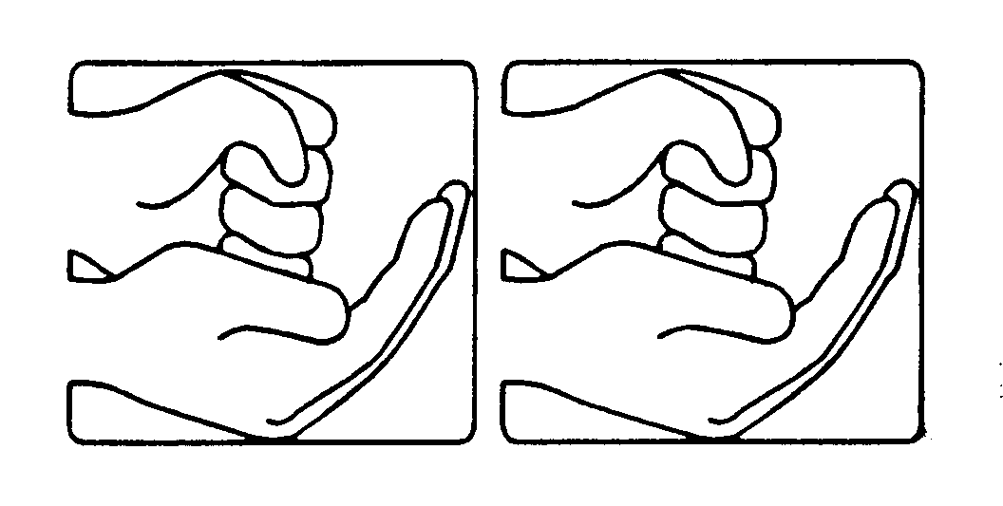
FOR DEAF AND HARD OF HEARING INDIVIDUALS

University of Minnesota Medical Center, Fairview Riverside

Intake Worksheet

Date ____/____/____
Potential Client’s Name: ____________________________________________________________ M F
Address: ______________________________________________________________________________
______________________________________________________________________________
Phone/TTY/Video phone:____________________________ Email: __________________________________
What is the best way to contact you? ________________________ S.S.#: _____________________________
D.O.B.: ____/____/____ Age: ______________ Fairview MR# (if known) _______________________
Single Married Partnered Divorced Legally Separated Widowed
What method(s) of communication do you prefer? Please circle: written English spoken English
American Sign Language Signed Exact English Pidgin Signed English Cued speech
Lip/speech reading other ________________________________________________________________
Do you use assisted listening devices? _______________ Type: _____________________________________
Referral Source: ____________________________________________________________________________
Address: ______________________________________________________________________________
______________________________________________________________________________
Phone: ______________________________ Email: ___________________________________
How did you learn about our program? _______________________________________________________
Emergency Contact: __________________________________ Relationship: __________________________
Address: ______________________________________________________________________________
______________________________________________________________________________
Phone: (Home) ___________________________ (Other) ________________________________________
E-Mail: ______________________________________________________________________________
Primary Insurance
Insurance Company: ________________________________________________________________________
Policy holder: _______________________________________________________ DOB: ____/____/_____
SS/ID/Policy #: _________________________________ Group Number: _____________________________
Payer’s phone number/contact information: ____________________________________________________
Secondary Insurance (if applicable)
Insurance Company: _________________________________________________________________________
Policy holder: _______________________________________________________ DOB: ____/____/_____
SS/ID/Policy #: _________________________________ Group Number: _____________________________
Payer’s phone number/contact information: ____________________________________________________

Primary Care Physician
Name ____________________________________
Address___________________________________
__________________________________________
Phone_____________________________________

Secondary Physician/Psychiatrist
Name _______________________________
Address______________________________
_____________________________________
Phone________________________________

You are encouraged to provide Fairview with any relevant medical records.

In order for this worksheet to be processed, it must be
accompanied by a copy of your
insurance, Medicare, and/or Medicaid cards.

Prior chemical dependency or mental health treatment:
Name of facility | Inpatient | Outpatient | Dates  attended

History of alcohol and other drug use
First, please tell us what substances you are CURRENTLY using:
Type of substance | Amount typically used | How often/how many times a week | Date of last use | How long you have used

Please also tell us what substances you have used in the past:
Type of substance | Amount typically used | How often/how many times a week | Date of last use | How long you used

How old were you when you got drunk or used drugs for the first time? _________________________________
Why have you used these drugs? ___________________________________________________________________
_________________________________________________________________________________________________
Any prescription drugs or over-the-counter medications currently being used: ____________________________
_________________________________________________________________________________________________
Do you use tobacco or nicotine? If so, type and frequency of use: ________________________________________
_________________________________________________________________________________________________
Psychological history:
Previous or current diagnoses: _____________________________________________________________________
_________________________________________________________________________________________________
Behavioral issues, such as suicide attempts, aggression, etc. __________________________________________________________________________________________________________________________________________________________________________________________________

Medical conditions and concerns:
Physical concerns, such as diabetes, seizures, chronic pain, vision or mobility barriers, etc. __________________________________________________________________________________________________________________________________________________________________________________________________
Are you independent in all activities of daily living? If not, please explain the type of assistance needed:
_________________________________________________________________________________________________
_________________________________________________________________________________________________
Legal consequences:
Legal history, such as arrests, DUI/DWI, probation, parole, assaults, property damage, theft, etc.
__________________________________________________________________________________________________________________________________________________________________________________________________
Do you have a parole/probation officer? If so, name: ___________________________________________________
County and state: _______________________ Phone: _____________________ Email: _______________________
Family consequences and concerns:
Issues such as arguments, fights, domestic violence, abuse, etc. _________________________________________
__________________________________________________________________________________________________________________________________________________________________________________________________
Any children/dependents? Please list: _______________________________________________________________
Financial consequences and concerns:
Issues such as unpaid bills, large debt, borrowing money from others, etc. _______________________________
_________________________________________________________________________________________________
_________________________________________________________________________________________________
Work or school consequences and concerns:
Issues such as poor performance, absenteeism, terminations, etc. ________________________________________
_________________________________________________________________________________________________
_________________________________________________________________________________________________
Patient’s Occupation: ______________________________________________________________________________
Employer: _____________________________ Phone: ____________________________________________________

In the past 30 days:
Have you been arrested and if so, how many times? ___________________________________________________
How many of these arrests have been alcohol or drug related? __________________________________________
How many nights have you spent in jail? _____________________________________________________________
How many days have you used alcohol in the past 30 days? ____________________________________________
On how many of those occasions did you use 5 or more drinks in one setting? _____________________________
How many drinking occasions were four drinks or fewer in one setting? __________________________________

For professional referral source (social worker, counselor, etc.) use only: Are there options to support sobriety after treatment is completed? Include ideas for outpatient treatment, sober housing, and changes in living arrangements, etc. _______________________________________________________________________________
________________________________________________________________________________________________
________________________________________________________________________________________________

When this form is completed,
please submit it to our Intake Coordinator by fax, email, or mail.
If you have questions about this form or need assistance filling it our,
please contact us and we will be happy to help.

Minnesota Chemical Dependency Program

for Deaf and Hard of Hearing Individuals
University of Minnesota Medical Center, Fairview, Riverside Campus

2450 Riverside Avenue South

Minneapolis MN 55454
(800) 282-3323 (voice/TTY)
(612) 273-4402 (voice/TTY/video phone)
(612) 273-4516 (fax)
Email us at deafhoh1@fairview.org
Visit our website at www.mncddeaf.org
Learn more about our company at www.fairview.org
Learn more about our facility at www.uofmmedicalcenter.org

10/07 ML

